Insert your name, centre number and candidate number into the header above.
Save this evidence document as evidence_ followed by your centre number_ candidate number. For example: evidence_ zz999_9999.doc
Screenshots or program listings must be copied into appropriate cells in the following tables.
Examiners must be able to read the contents including any screenshots without the use of a magnifying glass. Answers that are not readable or missing will not be awarded any marks.
Save this evidence document at regular intervals, for example, every 10 minutes.
Question 1
Part 1(a)
{Copy and paste program code listing for question 1(a) here}

#main
DataStored=[] # DECLARE DataStored: ARRAY[0:19] OF INTEGER
NumberItems=0

Part 1(b)
{Copy and paste program code listing for question 1(b) here}

def Initialise():
global DataStored
global NumberItems

Valid=False
while not Valid:
Quantity=int(input("Enter the number of quantity of the numbers, between 1 and 20 inclusive. "))
if Quantity>=1 and Quantity<=20:
NumberItems=Quantity
Valid=True
else:
print("Invalid number input.")

for i in range(NumberItems):
DataStored.append(int(input("Enter the number. ")))

Part 1(c)(i)
{Copy and paste program code listing for question 1(c)(i) here}

#main
DataStored=[] # DECLARE DataStored: ARRAY[0:19] OF INTEGER
NumberItems=0
Initialise()
print(DataStored)

Part 1(c)(ii)
{Copy and paste screenshot for question 1(c)(ii) here}

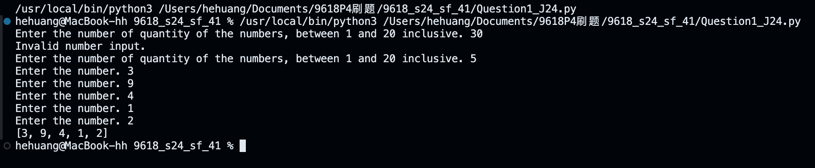

Part 1(d)(i)
{Copy and paste program code listing for question 1(d)(i) here}

def BubbleSort():
global DataStored
global NumberItems

Sorted=False
x=NumberItems
while not Sorted or x>=0:
Sorted=True
for i in range(x-1):
if DataStored[i]>DataStored[i+1]:
temp=DataStored[i+1]
DataStored[i+1]=DataStored[i]
DataStored[i]=temp
Sorted=False
x-=1

Part 1(d)(ii)
{Copy and paste program code listing for question 1(d)(ii) here}

#main
DataStored=[] # DECLARE DataStored: ARRAY[0:19] OF INTEGER
NumberItems=0
Initialise()
print(DataStored)
BubbleSort()
print(f"Sorted: {DataStored}")

Part 1(d)(iii)
{Copy and paste screenshot for question 1(d)(iii) here}
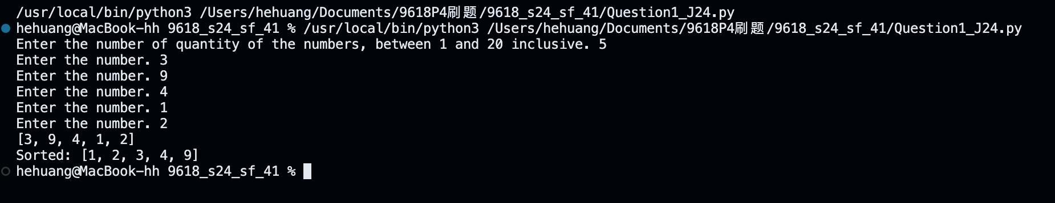

Part 1(e)(i)
{Copy and paste program code listing for question 1(e)(i) here}

def BinarySearch(DataToFind):
global DataStored
global NumberItems

lower=0
upper=NumberItems-1

while lower<=upper:
mid=(lower+upper)//2
if DataStored[mid]==DataToFind:
return mid
elif DataStored[mid]>DataToFind:
upper=mid-1
else:
lower=mid+1

return -1

Part 1(e)(ii)
{Copy and paste program code listing for question 1(e)(ii) here}

#main
DataStored=[] # DECLARE DataStored: ARRAY[0:19] OF INTEGER
NumberItems=0
Initialise()
print(DataStored)
BubbleSort()
print(f"Sorted: {DataStored}")

print(BinarySearch(int(input("Enter a number you want to find. "))))

Part 1(e)(iii)
{Copy and paste screenshot for question 1(e)(iii) here}

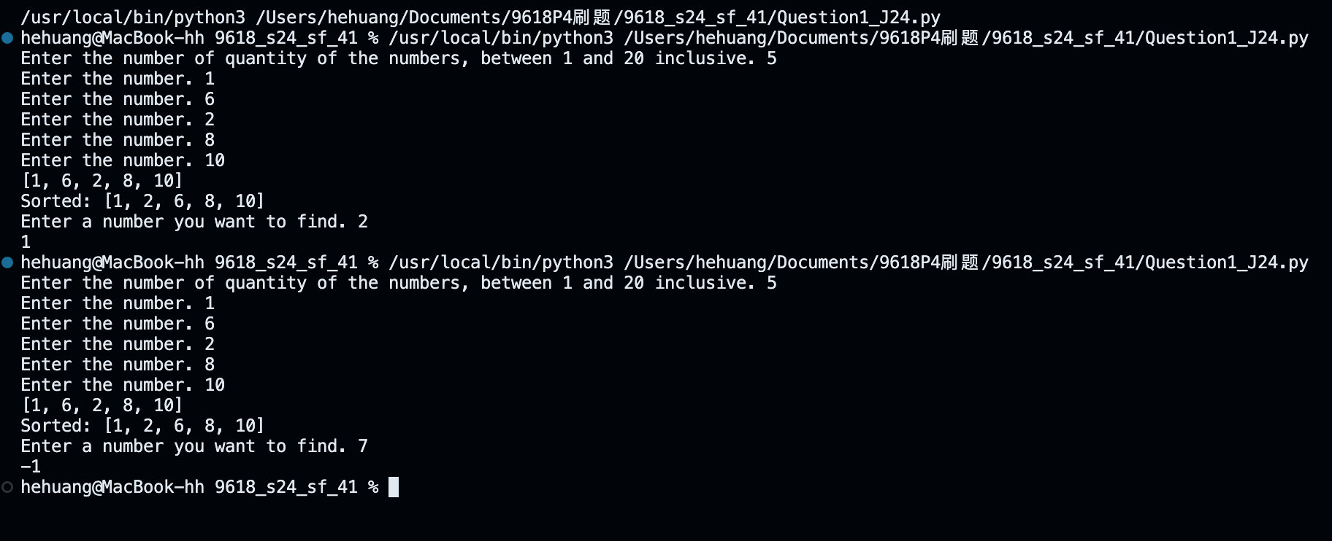

Question 2
Part 2(a)(i)
{Copy and paste program code listing for question 2(a)(i) here}

class Tree:
def __init__(self,tn,hg,mh,mw,evg):
self.__TreeName=tn # PRIVATE TreeName: STRING
self.__HeightGrowth=hg # PRIVATE HeightGrowth: INTEGER
self.__MaxHeight=mh # PRIVATE MaxHeight: INTEGER
self.__MaxWidth=mw # PRIVATE MaxWidth: INTEGER
self.__Evergreen=evg # PRIVATE Evergreen: STRING

Part 2(a)(ii)
{Copy and paste program code listing for question 2(a)(ii) here}

def GetTreeName(self): return self.__TreeName

Part 2(b)
{Copy and paste program code listing for question 2(b) here}

def ReadData():
try:
fr=open("Trees.txt",'r')
x=fr.readline().strip()
ArrayTree=[]

while x != "":
x=x.split(',')
ArrayTree.append(Tree(x[0],int(x[1]),int(x[2]),int(x[3]),x[4]))
x=fr.readline().strip()

fr.close()

except IOError:
print("File not found.")

return ArrayTree

Part 2(c)
{Copy and paste program code listing for question 2(c) here}
def PrintTrees(Tr):
print(f"{Tr.GetTreeName()} has a maximum height {Tr.GetMaxHeight()} a maximum width {Tr.GetMaxWidth()} and grows {Tr.GetHeightGrowth()} cm a year.", end=" ")
if Tr.GetEvergreen()=="No": print("It loses its leaves each year.")
else: print("It does not lose its leaves.")

Part 2(d)(i)
{Copy and paste program code listing for question 2(d)(i) here}

#main
Trees=ReadData()
PrintTrees(Trees[0])

Part 2(d)(ii)
{Copy and paste screenshot for question 2(d)(ii) here}

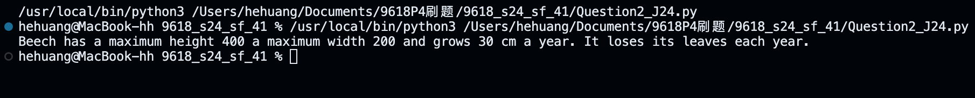

Part 2(e)(i)
{Copy and paste program code listing for question 2(e)(i) here}

def ChooseTree(ArrayOfTree):
mh=int(input("Enter the maximum height the tree can be in cm. "))
mw=int(input("Enter the maximum width the tree can be in cm. "))
evg=input("Do you expect the tree to be evergreen? Enter 'yes' or 'no'. ").lower()
AvaliableTree=[]

for EachTree in ArrayOfTree:
if EachTree.GetMaxHeight()<=mh and EachTree.GetMaxWidth()<=mw and EachTree.GetEvergreen().lower()==evg:
AvaliableTree.append(EachTree)

if len(AvaliableTree)==0:
print("There is no tree that meets your requirement.")
else:
for EachTree in ArrayOfTree:
PrintTrees(EachTree)

Part 2(e)(ii)
{Copy and paste program code listing for question 2(e)(ii) here}

def ChooseTree(ArrayOfTree):
mh=int(input("Enter the maximum height the tree can be in cm. "))
mw=int(input("Enter the maximum width the tree can be in cm. "))
evg=input("Do you expect the tree to be evergreen? Enter 'yes' or 'no'. ").lower()
AvaliableTree=[]

for EachTree in ArrayOfTree:
if EachTree.GetMaxHeight()<=mh and EachTree.GetMaxWidth()<=mw and EachTree.GetEvergreen().lower()==evg:
AvaliableTree.append(EachTree)

if len(AvaliableTree)==0:
print("There is no tree that meets your requirement.")
else:
for EachTree in AvaliableTree:
PrintTrees(EachTree)
WantedTree=input("Enter the name of one of the trees you want. ").lower()
TreeHeight=int("Enter the current height of the tree you expect. ")
for EachTree in AvaliableTree:
if EachTree.GetTreeName().lower()==WantedTree:
print(f"The tree will take {(EachTree.GetMaxHeight()-TreeHeight)//EachTree.GetHeightGrowth()} years to reach the maximum height {EachTree.GetMaxHeight()}cm.")

Part 2(e)(iii)
{Copy and paste screenshot for question 2(e)(iii) here}

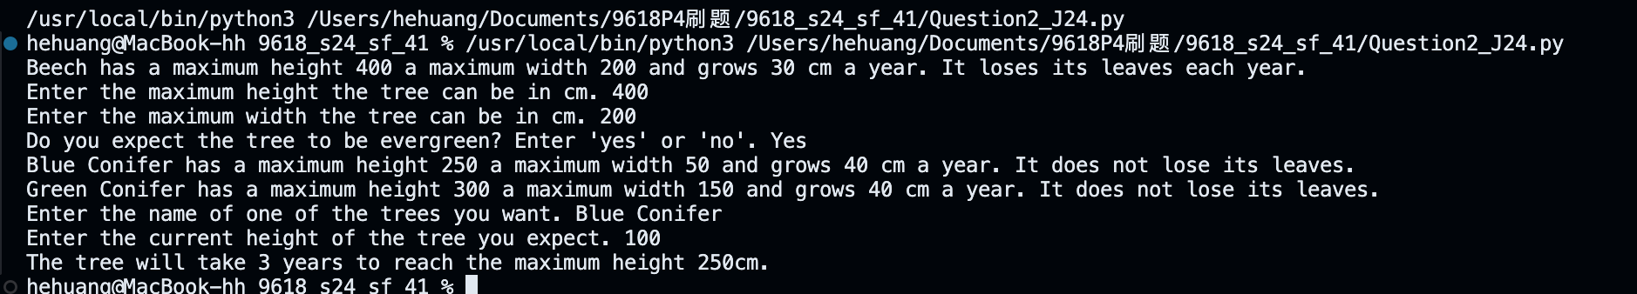

Question 3
Part 3(a)
{Copy and paste program code listing for question 3(a) here}

#main
QueueData=[None for _ in range(20)]
QueueHead=-1
QueueTail=-1

Part 3(b)
{Copy and paste program code listing for question 3(b) here}

def Enqueue(NewData):
global QueueData
global QueueHead
global QueueTail

if QueueTail>=19:
return False

QueueTail+=1
QueueData[QueueTail]=NewData

if QueueHead==-1:
QueueHead=QueueTail

return True

Part 3(c)
{Copy and paste program code listing for question 3(c) here}

def Dequeue():
global QueueData
global QueueHead
global QueueTail

if QueueTail<QueueHead:
return "false"

DataReturn=QueueData[QueueHead]
QueueHead+=1

return DataReturn

Part 3(d)(i)
{Copy and paste program code listing for question 3(d)(i) here}

def StoreItems():
CountInvalid=0
for i in range(10):
Digits=input("Enter a 7-character string. ")
CheckDigit=Digits[6]

if CheckDigit!='X':
CheckDigit=int(CheckDigit)
Sum=(int(Digits[1])+int(Digits[3])+int(Digits[5]))*3+(int(Digits[0])+int(Digits[2])+int(Digits[4]))*1
Result=Sum//10
if Result==0:
if CheckDigit=='X':
Inserted=Enqueue(Digits[0:6])
if Inserted: print("Successfully added.")
else: print("Queue is already full.")
else:
if Result==CheckDigit:
Inserted=Enqueue(Digits[0:6])
if Inserted: print("Successfully added.")
else: print("Queue is already full.")
else:CountInvalid+=1

print(f"There were {CountInvalid} invalid items entered.")

Part 3(d)(ii)
{Copy and paste program code listing for question 3(d)(ii) here}

#main
QueueData=[None for _ in range(20)]
QueueHead=-1
QueueTail=-1

StoreItems()
Item=Dequeue()
if Item == "false": print("The queue is empty.")
else: print(Item)

Part 3(d)(iii)
{Copy and paste screenshot for question 3(d)(iii) here}

